https://www.officemag.ru/catalog/goods/116407/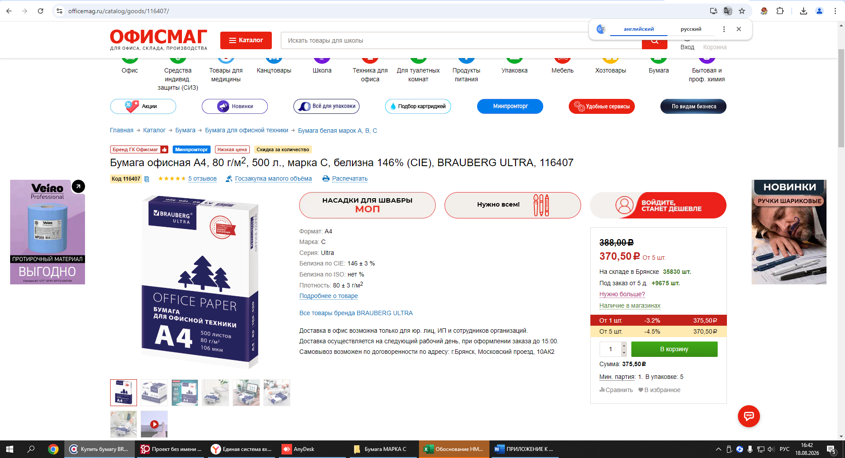https://www.komus.ru/katalog/bumaga-i-bumazhnye-izdeliya/bumaga-dlya-ofisnoj-tekhniki/formatnaya-bumaga/bumaga-formatnaya-belaya-dlya-ofisnoj-tekhniki/bumaga-ofisnaya-komus-dokument-standard-a4-80-g-kv-m-marka-s-146-cie-500-listov-/p/90391/?utm_content=%7Cc%3A702783908%7Cg%3A5631255866%7Cb%3A1885239312197664323%7Ck%3A205631255866%7Cst%3Asearch%7Ca%3Ano%7Cs%3Anone%7Ct%3Apremium%7Cp%3A2%7Cr%3A205631255866%7Cdev%3Adesktop&utm_term=---autotargeting&utm_source=context4-yandex_ad-mgc-v4&utm_medium=cpc&utm_campaign=context4-dinam2_usilenie_stm_komus-poisk-op_z1-nbr-ntr-ntm-v4&yclid=2591069258593861631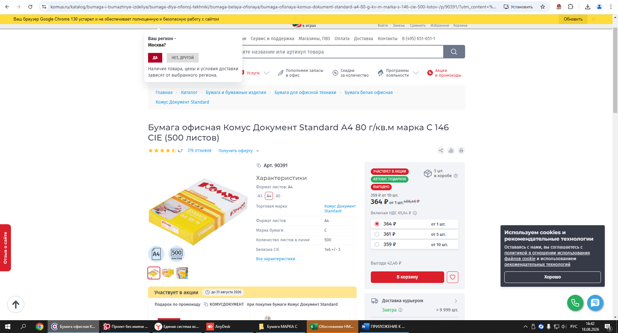
https://xn----gtbdnnh3a.xn--p1ai/catalog/bumaga/bumaga-dlya-orgtekhniki/bumaga-belaya-klassov-a-v-s/?yclid=6489845321392193535