https://robotbaza.ru/product/mobilnaya-stoyka-dlya-interaktivnyh-paneley-hy-680a-49-86?calltouch_tm=yd_c:706583221_gb:5705039257_ad:17557316151_ph:205705039257_st:search_pt:dynamic_places_p:1_s:yandex.ru_dt:desktop_reg:213_ret:205705039257_apt:none&utm_medium=cpc&utm_source=yandex&utm_campaign=Interwrite.&utm_content=17557316151&utm_term=---autotargeting&etext=&yclid=5521790431445385215&ybaip=1
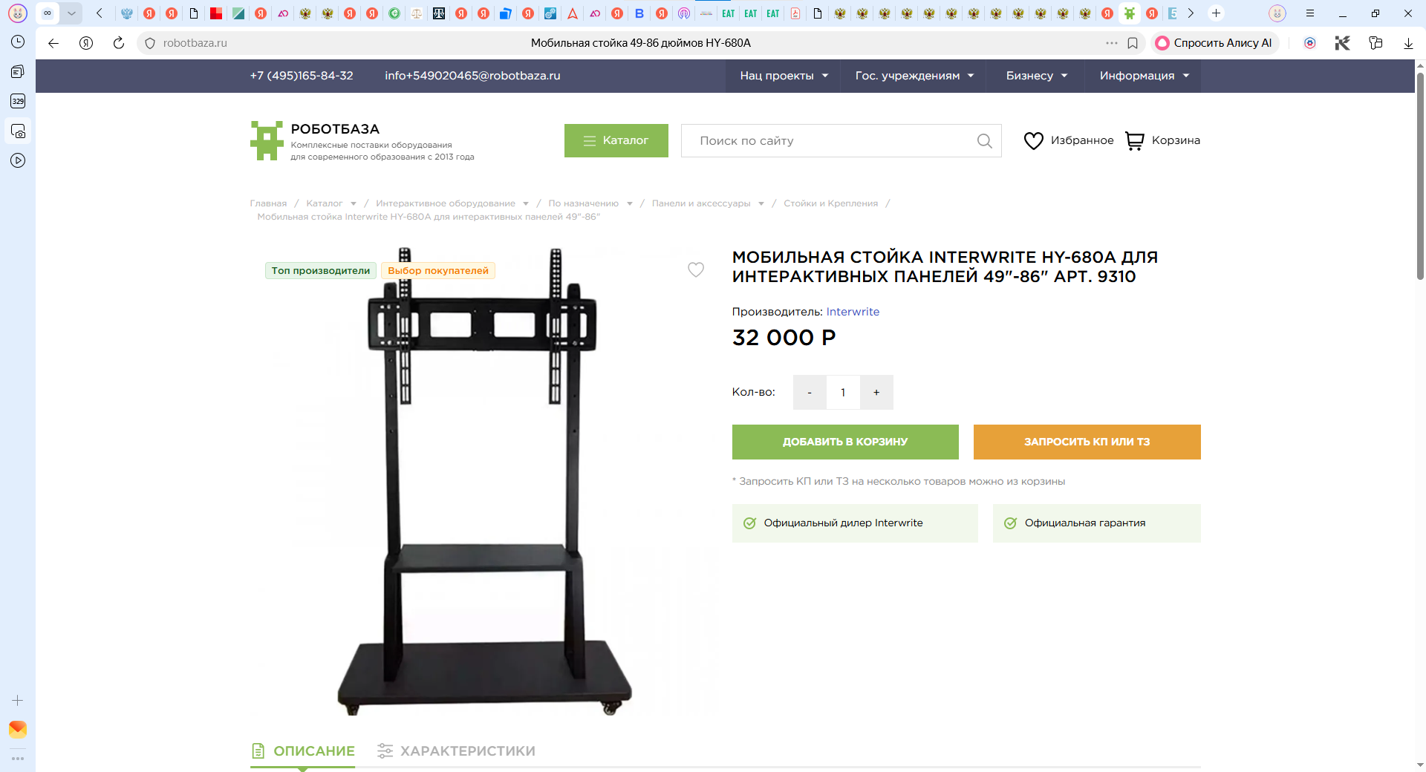

https://childresidence.ru/products/mobilnaya-stoika-interwrite-hy-680a-dlya-interaktivnykh-panelei-49-86?ysclid=mpyd1na3gx238097785
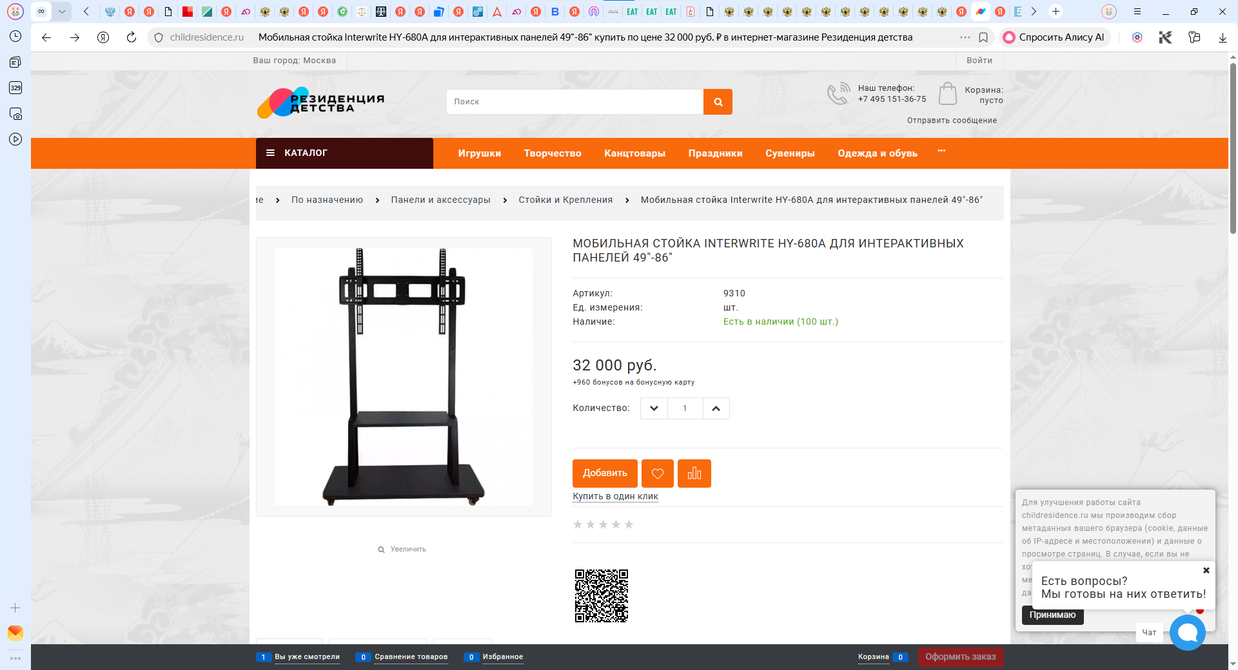

https://zvk.ru/catalog/krepleniya-i-stoyki/mobilnye-napolnye-stoyki/mobilnaya-stoyka-dlya-interaktivnykh-paneley-hy-680a/?ysclid=mpyd2r3wx7883045886
