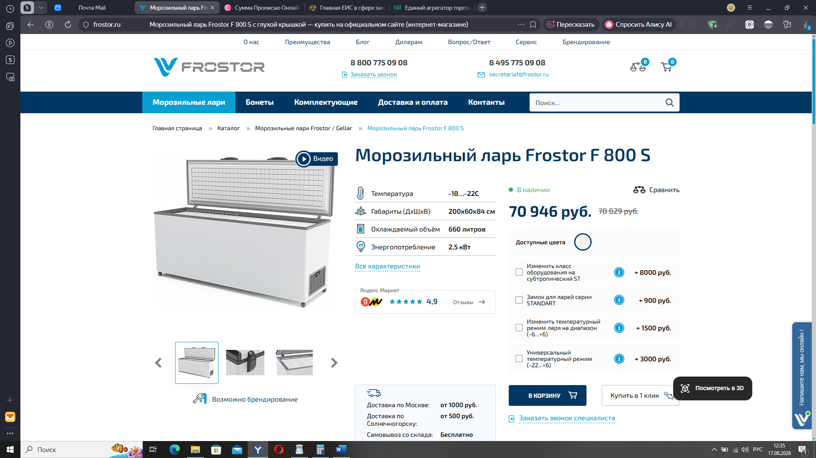
https://frostor.ru/catalog/morozilnye_lari/f-800-s/

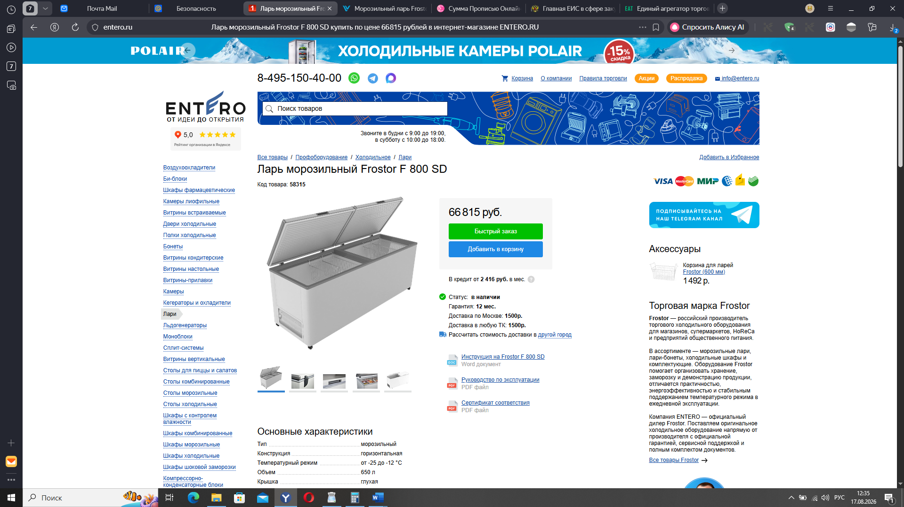
https://entero.ru/item/58315?srsltid=AfmBOooiwlzFU9NCAEtuTG269BCWFcdtUGOcRjSV3Fo7-482c0SMWLrL

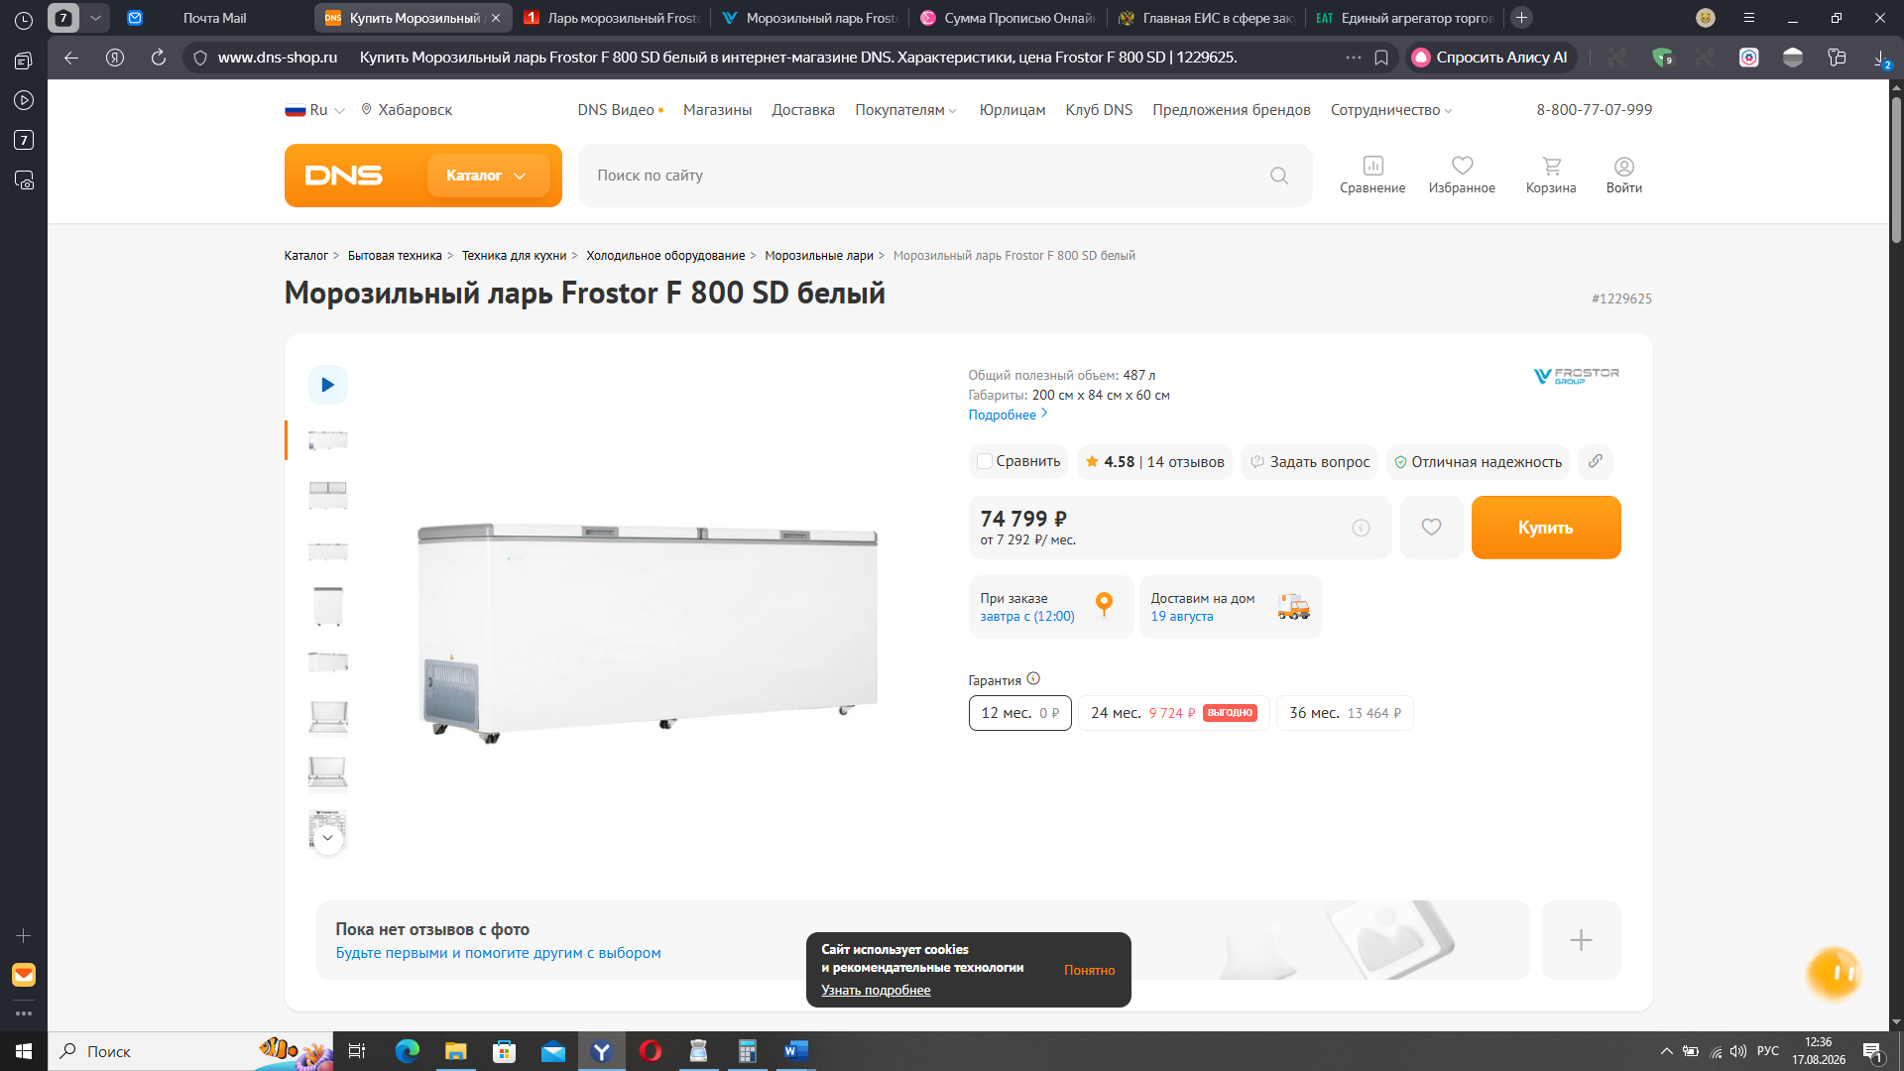
https://www.dns-shop.ru/product/46760be22b123330/morozilnyj-lar-frostor-f-800-sd-belyj/?utm_medium=organic&utm_source=google&utm_referrer=https%3A%2F%2Fwww.google.com%2F

