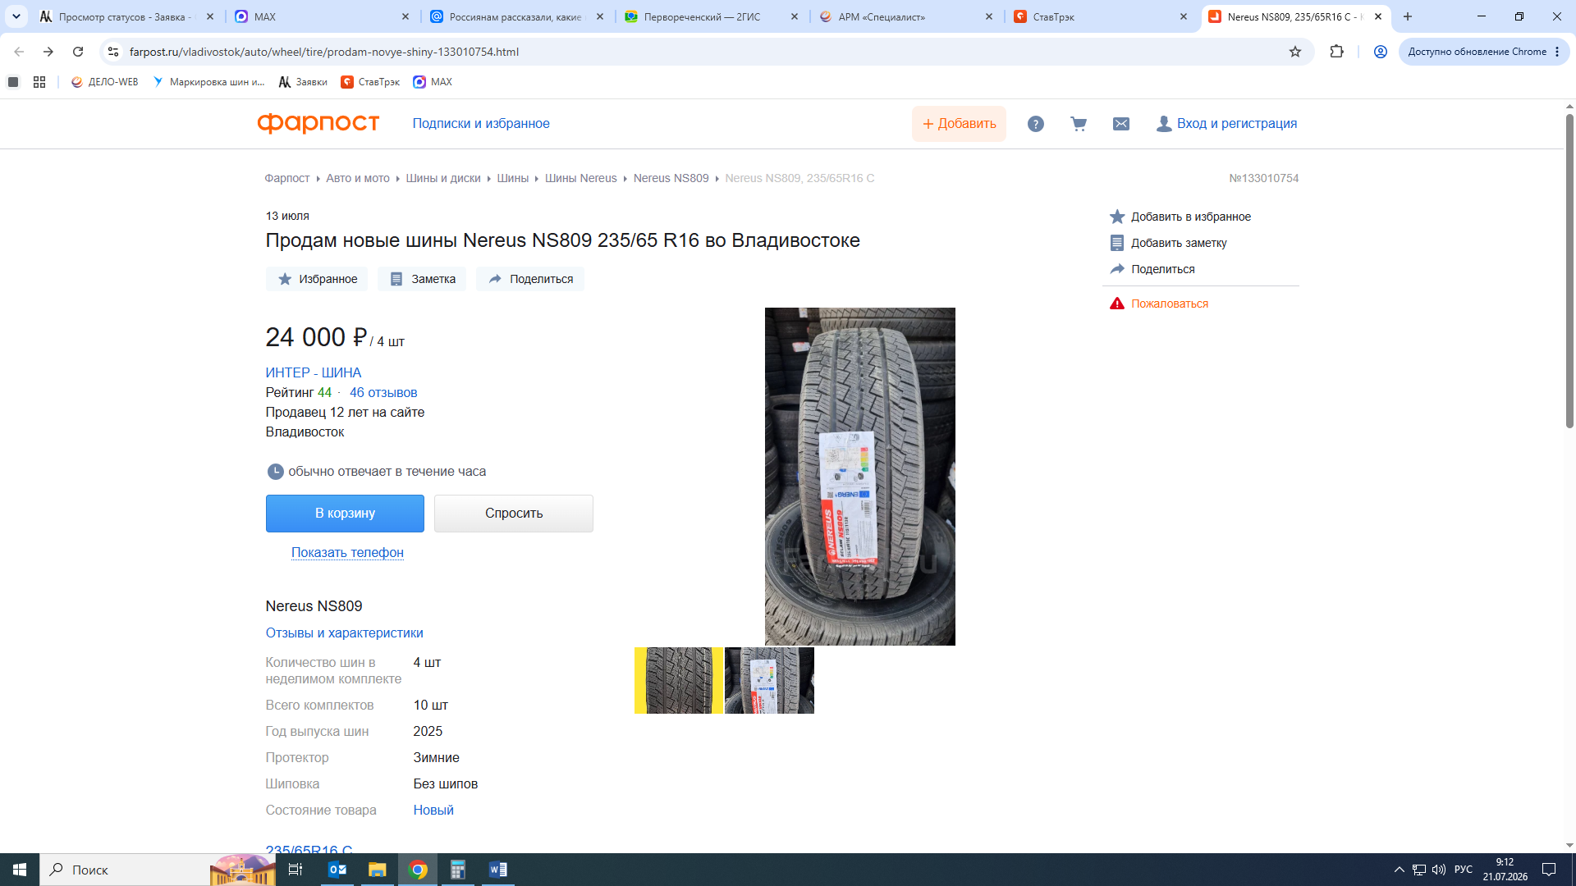

https://www.farpost.ru/vladivostok/auto/wheel/tire/prodam-novye-shiny-133010754.html

