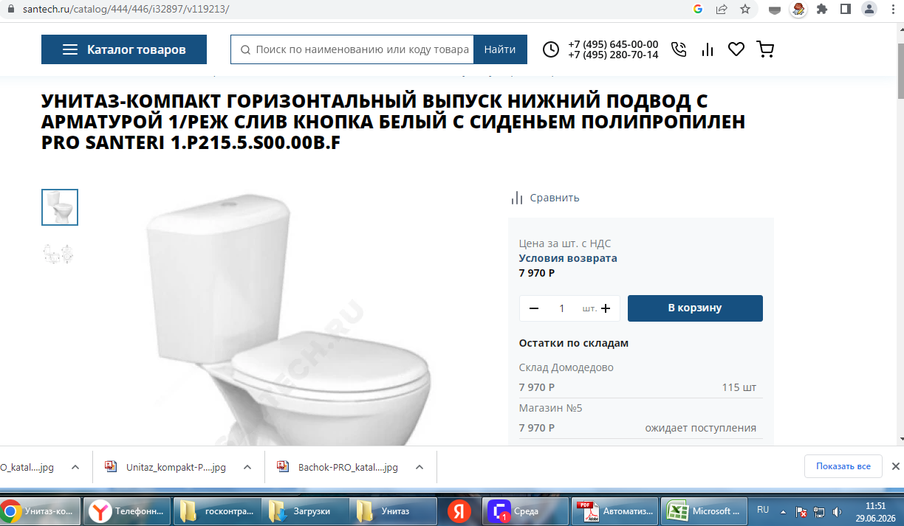https://www.santech.ru/catalog/444/446/i32897/v119213/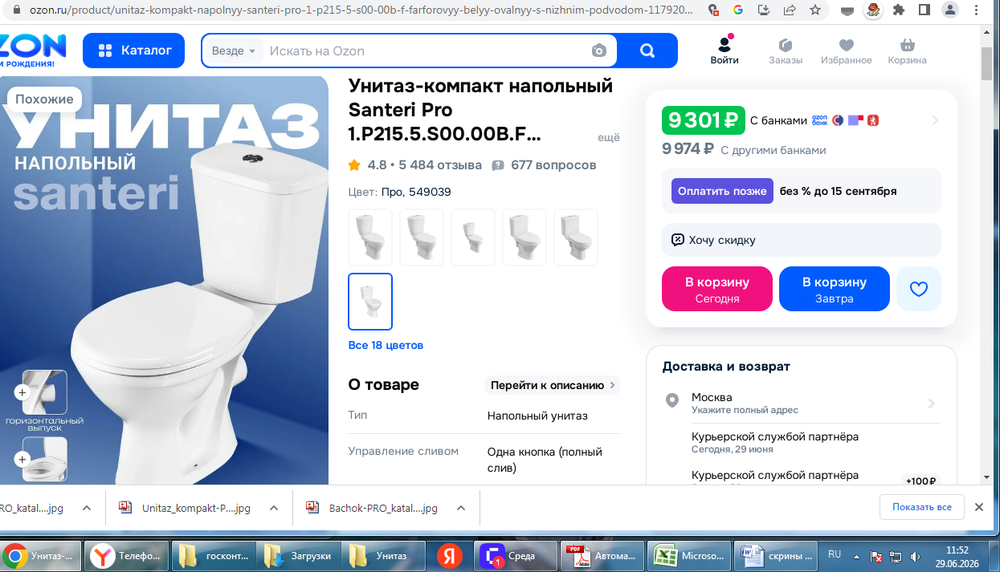https://www.ozon.ru/product/unitaz-kompakt-napolnyy-santeri-pro-1-p215-5-s00-00b-f-farforovyy-belyy-ovalnyy-s-nizhnim-podvodom-1179204988/
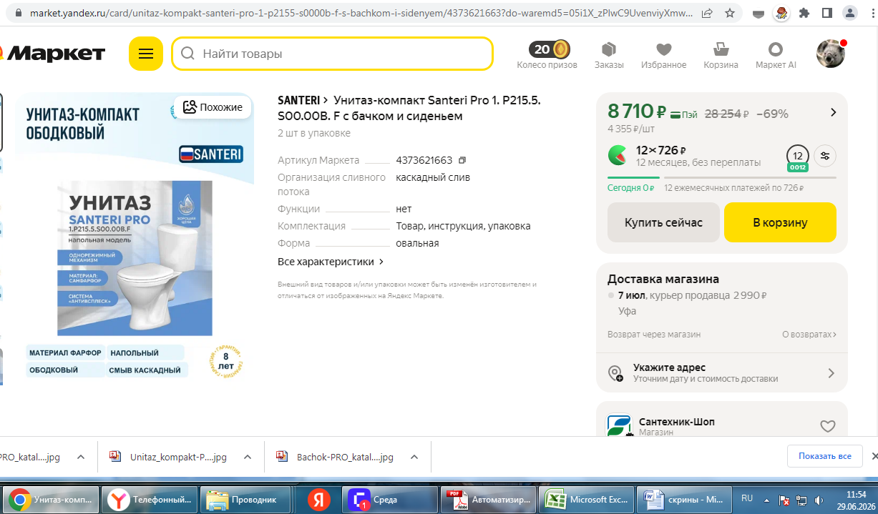https://market.yandex.ru/card/unitaz-kompakt-santeri-pro-1-p2155-s0000b-f-s-bachkom-i-sidenyem/4373621663?do-waremd5=05i1X_zPlwC9UvenviyXmw&cpc=CzCsFnmVgvIw8u8xSm2RkSuxxwqppiu6oZxcebAdneVMc7HvKrhPskV3T1H_y-u4KzkPGmNr-2NBJp_HQVyVqDKFLmRd5u1aWa6JiqCA859aT_YO3dt1uy6enI_UJxLS4t25JBzlXn3Ltz0mot-R4BRSCCW3wdfb9jE9aOPIlWgc46jJoj0hlPxUGnjJV83Qg3zDIcBD3cUVO3G-cVKoBTTT3dazRaOgDUQILK73GzPuqr0NVuryiU9FWYnmJ3zl_XuXFPXLzKRuUQyUxPZZm4DSlVWGtzTdT9MlJkGuQtCmWjJizwIGVkxqXT6h52AYEntUVg2J3OpmD0RAU8rmxlAjNnm3mbO-wTFIM8XERkDYboOgfrLVQRiD0kE5ZbZSuJMAT00JunWXbTH_A_VgJ0y2yWr-AmoDj4mtUuz8oxMcQhghBfruxoecAaKPrIG01fdNjSD4oDWW3OhZ1z-BquSU58UxJRs3&nid=61555561&ogV=-12

