- Стол
https://www.express-office.ru/catalog/stoly/peregovornie-stoly/stol-dlya-peregovorov-style-project-sn-6sprg-713-tikvud-svetlyj-metall-belyj/
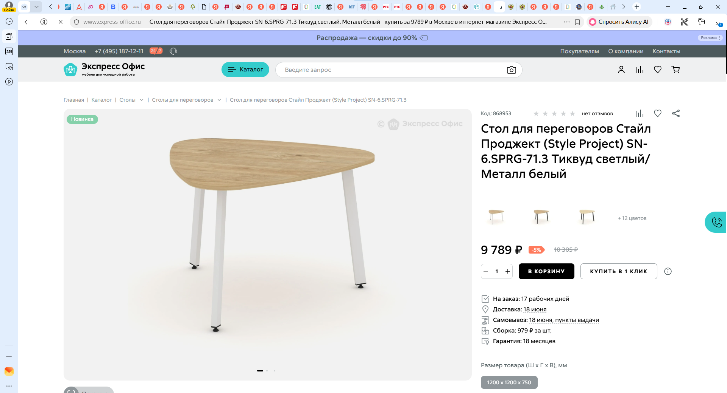

https://www.komus.ru/katalog/mebel/ofisnaya-mebel/mebel-dlya-personala/stoly-dlya-personala/stoly-peregovorov-dlya-personala/stol-dlya-peregovorov-style-project-sn-6-sprg-71-3-akatsiya-lorka-belyj-1200kh1200kh750-mm-/p/2313547/?from=var
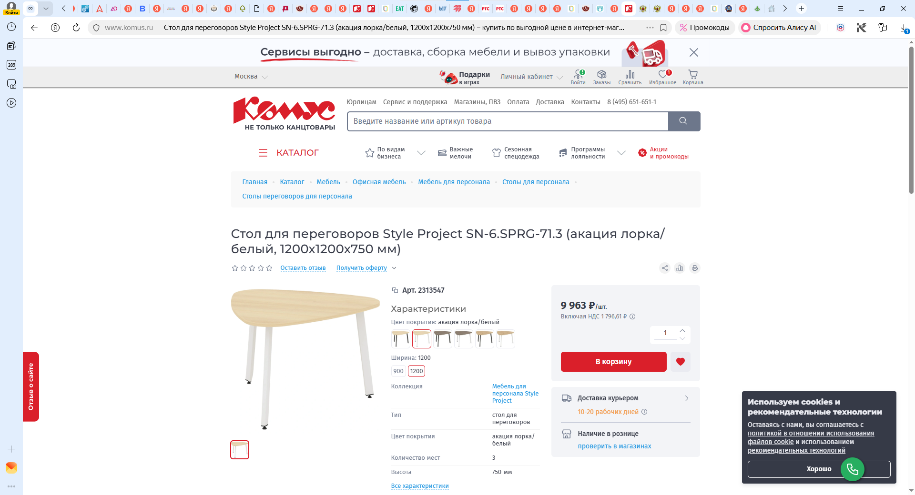

https://zakazat-mebel.ru/catalog/kollektsii_i_serii/serii-ofisnoy-mebeli/serii-dlya-personala/stayl-prodzhekt-style-project/akatsiya-lorka/stoly-peregovornye/stayl-prodzhekt-stol-peregovornyy-sn-6-sprg-71-3-akatsiya-lorka-metall-belyy-1200-1200-750/

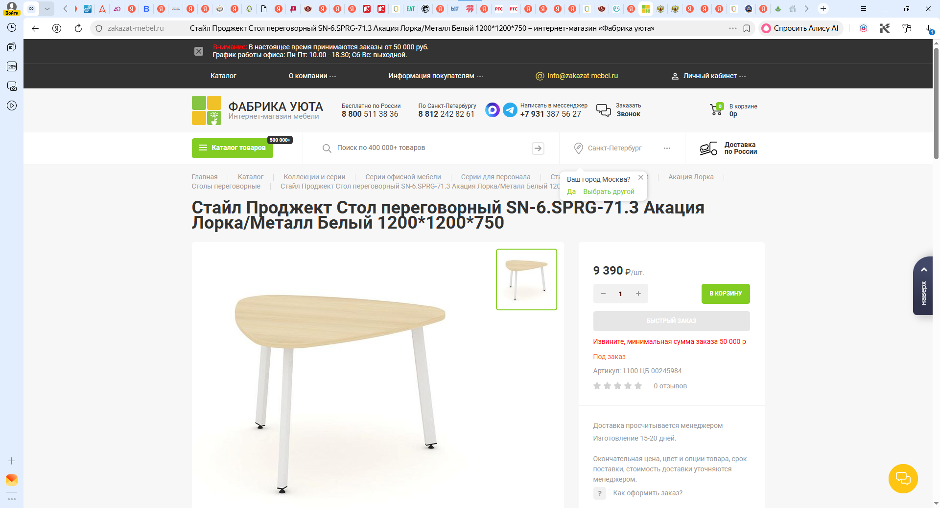

2 Стул
https://www.ofsi.ru/product/stul_obedennyy_komus_meri_bezhevyy_tkan_metall.html?ysclid=mpftm5yh1w900767259
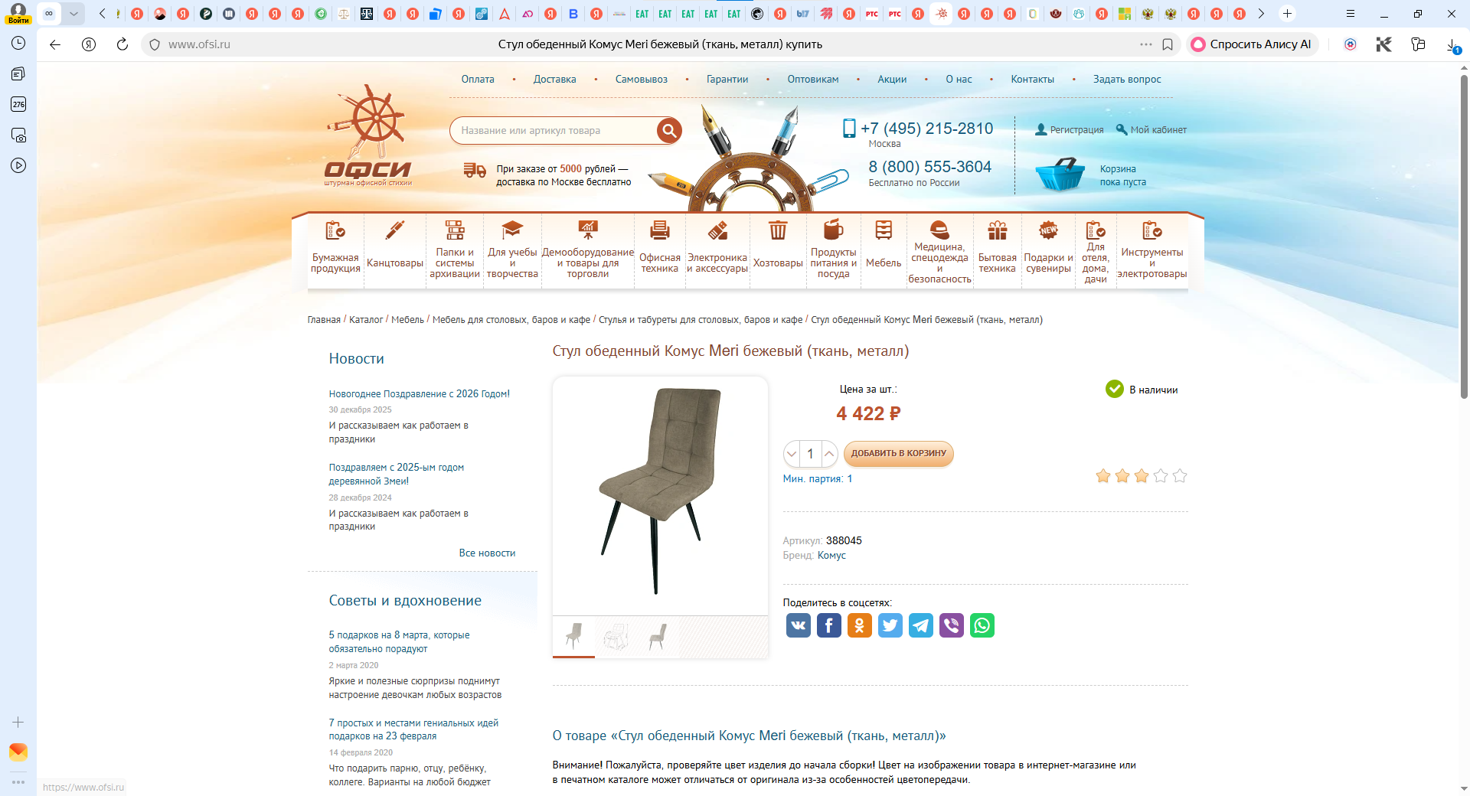

https://qpkresla.ru/catalog/stulya_ob/stulya_dlya_kukhni/stul_mate_seryy/
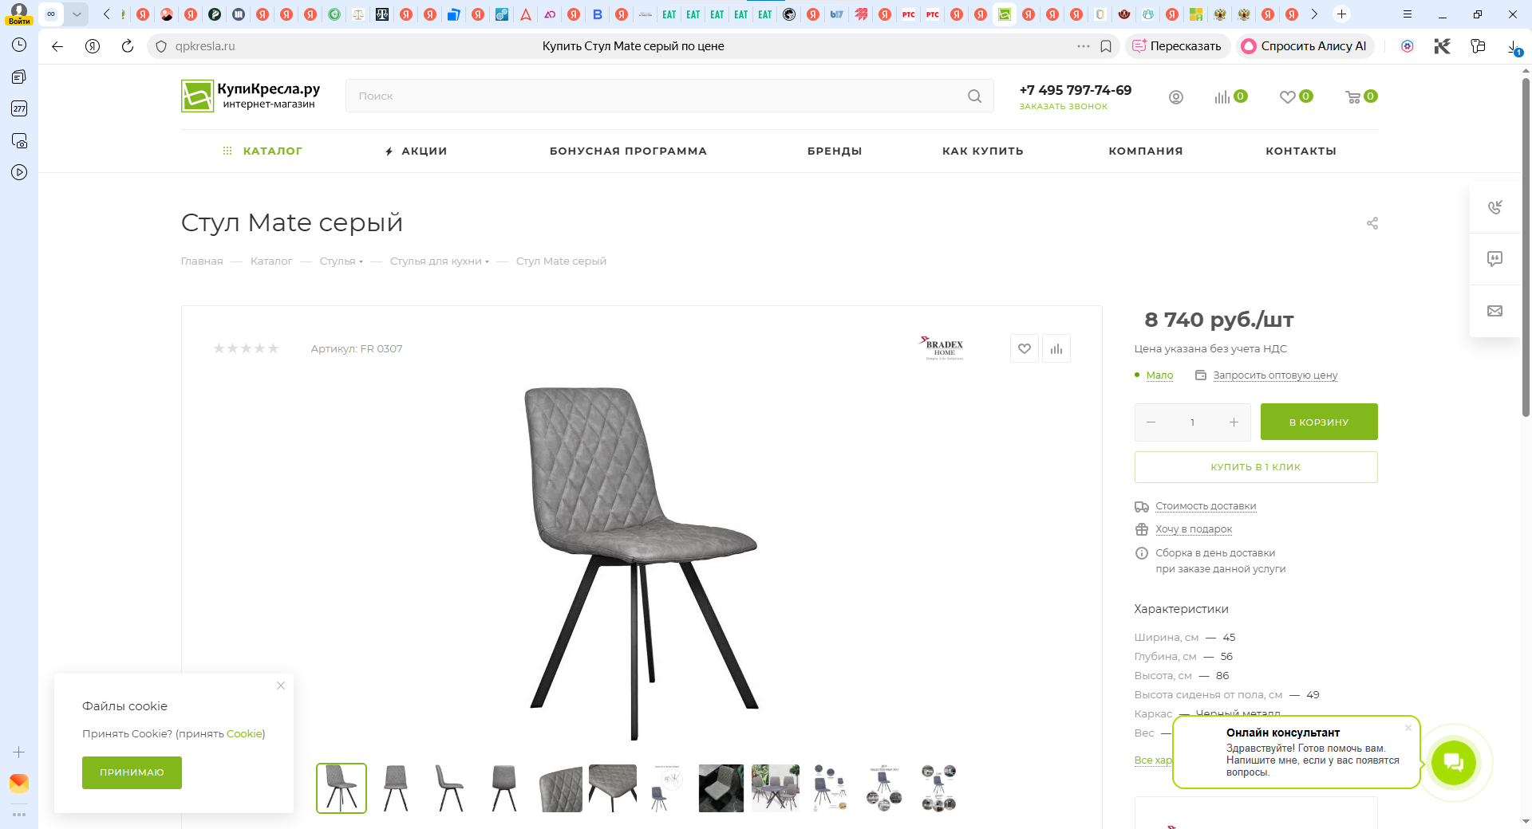

https://moscow.mebelverona.ru/stulya/stul-povorotnyj-ejden-m-chernyj-h75-chernyj/
