Reconstruction and Paleogenetic Characterization of the Genome of Princess Maria Vsevolozha, Wife of Grand Prince Vsevolod “the Big Nest”
K. V. Zhur¹, M.V. Leonova¹, F. S. Sharko³, E. D. Pankratova¹, A. V. Sirenov⁴, D. S. Korobov², M. V. Dobrovolskaya², N. A. Makarov², E. B. Prokhortchouk^{1*}
¹ Federal Research Centre “Fundamentals of Biotechnology” of the Russian Academy of Sciences, Moscow, 119071 Russian Federation
² Institute of Archeology, Russian Academy of Sciences, Moscow, 117292 Russian Federation
³ National Research Center “Kurchatov Institute”, Moscow, 123182, Russia
⁴ Saint Petersburg Institute of History of the Russian Academy of Sciences, St. Petersburg, 197110, Russia
* Email: prokhortchouk@gmail.com
ABSTRACT
Grand Prince of Vladimir Vsevolod “the Big Nest” and his wife Maria Vsevolozha (Shvarnovna) had twelve children, eight of whom were sons; their grandson was Grand Prince Alexander Yaroslavich Nevsky. Two competing hypotheses exist regarding the origin of Maria Vsevolozha, attributing her either to Ossetian or to Czech nobility. Maria Shvarnovna was buried in the Knyaginin Monastery in Vladimir. Although her remains were reinterred several times, they were never moved from the original burial location. During restoration works in 2015, skeletal remains, presumably belonging to Maria Shvarnovna, was sampled for paleogenetic analysis in order to determine their origin.
More than 144,000 single nucleotide polymorphisms (SNPs) were identified. Their analysis demonstrated that the remains belong to a female individual carrying mitochondrial haplogroup U4b1a4 and unambiguously confirmed a third-degree biological relationship (great-grandmother–great-grandson) with Prince Dmitry Alexandrovich, the son of Grand Prince Alexander Yaroslavich Nevsky. This result fully corresponds to the genealogical relationships described in medieval chronicles. Multivariate statistical analysis of the genome revealed two most probable proximal genetic sources of her origin: an Alan component, understood here in a broad cultural-historical sense encompassing populations of the Early and High Middle Ages, and an East Eurasian component. Among medieval populations, the genome of Maria Shvarnovna shows the closest genetic affinity to individuals associated with the Saltovo-Mayaki archaeological culture, characteristic of the forest-steppe Don region and formed as a result of the migration of Alan tribes, as well as to individuals from the Kara-Zhygach necropolis (14th century), whose genomes also consist of a dominant Alan and a minor East Eurasian component.
The obtained results not only support the Alan hypothesis and reject the Czech origin of Maria Shvarnovna, but—due to the confirmed biological relationship with her great-grandson Dmitry Alexandrovich—also allow a confident assertion of the reliable genetic identification of early representatives of the Rurikid princely dynasty.
KEYWORDS
Rurikids; Princess Maria Shvarnovna; Alan origin; ancient DNA; whole-genome sequencing; IBD analysis.
ABBREVIATIONS
aDNA – ancient DNA; SNP – single nucleotide polymorphism; PCA – principal component analysis.
INTRODUCTION
The study of the genetic profile of medieval members of the Rurikid dynasty requires the inclusion of as wide a range as possible of skeletal remains from burials of representatives of this princely lineage. The main difficulties arise from the current condition of medieval necropolises, which only rarely allow reliable personal identification of burials belonging to the Old Russian elite. The first reliable genetic data on medieval Rurikids, obtained from bone tissue samples from the burial of Prince Dmitry Alexandrovich in the Transfiguration Cathedral of Pereslavl-Zalessky, demonstrated the prospects for identifying securely attributed remains of other members of the princely family in historical necropolises of North-Eastern Rus’ [1].
One such site is the necropolis of the Knyaginin Monastery in Vladimir, known as the burial place of princesses of the Vladimir princely house [2]. According to the chronicle tradition, the founder of the Knyaginin Monastery was Maria Vsevolozha (Maria Shvarnovna), the wife of Vsevolod “the Big Nest” and the mother of his twelve children. According to the chronicles, in 1200 Vsevolod founded “a stone church in the name of the Dormition of the Holy Mother of God in the convent of the princess” [3]. In 1201, Maria’s sister, the wife of Prince Yaroslav Vladimirovich, was buried in the monastery; in 1205, the daughter of Maria and Vsevolod, Elena, was interred there [3]; and in 1206 Maria was buried there [4].
The ambiguity of historical sources and the complex history of multiple reburials associated with reconstructions of the Dormition Cathedral (Supplementary 1) explain the sustained scholarly interest in the skeletal remains that may belong to Princess Maria and her relatives.
In 2015, during reconstruction works beneath an arcosolium in the wall of the northern aisle of the cathedral, remains of four individuals were discovered: a woman aged 45–50 years (Individual No. 1), a woman aged 25–30 years (Individual No. 2), a child approximately 9 years old (Individual No. 3), and a young individual of undetermined sex represented only by a fragment of the occipital bone (Individual No. 4) [5]. The initial examination of both the context of the finds and the skeletal material was conducted by S. A. Nikitin and T. D. Panova [5].
Subsequently, detailed craniological, osteological, and paleopathological studies of three individuals were carried out, and a facial reconstruction was performed based on the skull of Individual No. 1, belonging to the older woman. The authors compared individual craniological features of skull No. 1 and demonstrated its morphological affinity to female skulls from the medieval Zmeysky burial ground in North Ossetia, representing the Alan tradition of the 10th–14th centuries, which may serve as a basis for the hypothesis of an Alan origin. Paleopathological analysis of the skeleton of Individual No. 1 revealed multiple age-related degenerative-dystrophic changes in the spine and on articular surfaces, interpreted by the authors as osteochondrosis and arthrosis with signs of inflammatory processes [5], which could have caused chronic pain.
Mitochondrial genome analysis was also performed, revealing identity of the mitochondrial DNA sequence (U4b1a4) in Individuals No. 1 and No. 3. K. A. Averyanov suggested that Individual No. 1 represents Maria Shvarnovna, Individual No. 2 represents Anna, the second wife of Vsevolod “the Big Nest,” and Individual No. 3 represents Eudokia, the daughter of Alexander Nevsky [6]. V. I. Merkulov, in contrast, proposed that Individual No. 1 belonged to the first wife of Alexander Nevsky (daughter of Prince Bryachislav of Polotsk), Individual No. 2 to Vasilisa, the wife of Andrey Alexandrovich of Gorodets (son of Alexander Nevsky), and Individual No. 3 to Eudokia, the daughter of Alexander Nevsky [7,8].
Confirmation or refutation of the hypothesis attributing Individual No. 1 to Princess Maria has only now become possible following the publication of whole-genome data from a confirmed representative of the Rurikid dynasty—Prince Dmitry Alexandrovich [1].
EXPERIMENTAL SECTION
All ancient DNA (aDNA) work was conducted in a dedicated clean-room facility at the Federal Research Center of Biotechnology of the Russian Academy of Sciences (K. G. Skryabin Institute of Bioengineering). DNA was extracted from a tooth fragment (incisor) using a magnetic separation method [9]. Sequencing libraries were prepared using the xGen™ ssDNA & Low-Input DNA Library Preparation Kit (IDT, USA). Target enrichment of genomic regions of interest was performed using the MyBaits Expert Human Affinities Prime Plus Kit (Daicel Arbor Biosciences). Sequencing was carried out on an Illumina HiSeq 1500 platform (Illumina, USA) in paired-end mode (2 × 150 bp). Filtering of contaminating DNA reads was performed using BBDuk [10]. Downstream data processing was conducted using the PALEOMIX pipeline (version 1.2.14) [11], including adapter trimming [12] and alignment of reads to the human reference genome (hg19/GRCh37) [13]. Quality filtering, indexing, sorting, and duplicate removal (rmdup) were performed using samtools (version 1.9) [14]. Genotypes were called using PileupCaller with the “–randomHaploid” option. Patterns of post-mortem DNA damage were assessed using MapDamage2 [15]. To determine clustering of the studied sample among published ancient genomes from the Allen Ancient DNA Resource (AADR) panel [16], ADMIXTURE v1.3.0 was used [17]. SNPs were pruned for linkage disequilibrium using PLINK v1.9 (–indep-pairwise 50 5 0.2) [18]. The number of clusters (K) ranged from 4 to 12 (Supplementary 2). Principal component analysis (PCA) was performed using the smartpca tool from the EIGENSOFT package. The list of samples included in the analyses is provided in Supplementary 3. Mitochondrial haplogroups were assigned using HaploGrep [19]. Genome modeling was performed using qpWave and qpAdm with the option “allsnps: YES”. Relatedness analysis was conducted using IBD-based methods [20] and READ [21]. Phenotypic traits were inferred using the HIrisPlex-S online tool [22,23]. Sequencing data for the MSh sample (laboratory ID P145) are publicly available at russiangenome.ru/P145.bam.
RESULTS AND DISCUSSION
Ancient DNA sequencing results of remains presumably belonging to Princess Maria Shvarnovna
The sequencing results of the DNA library prepared from genetic material presumed to belong to Princess Maria Shvarnovna are presented in Table 1 of Supplementary 4. The endogenous DNA content was 1.7% (Figure 1, Supplementary 4). More than 304 million sequencing reads were generated, yielding 144,938 SNPs. Analysis of mitochondrial markers assigned the sample to haplogroup U4b1a4. Assessment of contamination levels revealed no detectable contamination in the analyzed sample (Tables 2–3, Supplementary 4). For the studied DNA sample, a sufficient number of SNPs enabling probabilistic phenotypic prediction was obtained. With the highest probability, the individual had blue eyes, light hair, and a dark (olive) skin tone (Table 4, Supplementary 4).
Testing the hypothesis of kinship between Princess Maria Shvarnovna and Prince Dmitry Alexandrovich
According to genealogical reconstructions of the Rurikid dynasty [24,25], Maria Shvarnovna is identified as the great-grandmother of Grand Prince Dmitry Alexandrovich (hereafter DA). Therefore, if the analyzed genome indeed belongs to Princess Maria Shvarnovna, a third-degree biological relationship between this genome and that of Prince DA—previously reconstructed in an earlier study [1]—is expected.
Verification of the degree of kinship between the two genomes was performed using IBD analysis. Figure 1 shows the distribution of the number of IBD segments and the total length of IBD segments exceeding 12 cM for sample pairs of different degrees of relatedness. A histogram of the distribution of shared haplotype block lengths is presented in Supplementary 5. The obtained values for the compared genomes correspond to a third-degree relationship, which is consistent with historical records indicating the burial of Prince DA’s great-grandmother in the necropolis of the Knyaginin Monastery. The third-degree relationship was independently confirmed using the READ tool [21] (Supplementary 6). In the following sections, the analyzed sample is referred to as the genetic material of Princess Maria Shvarnovna (hereafter MSh).
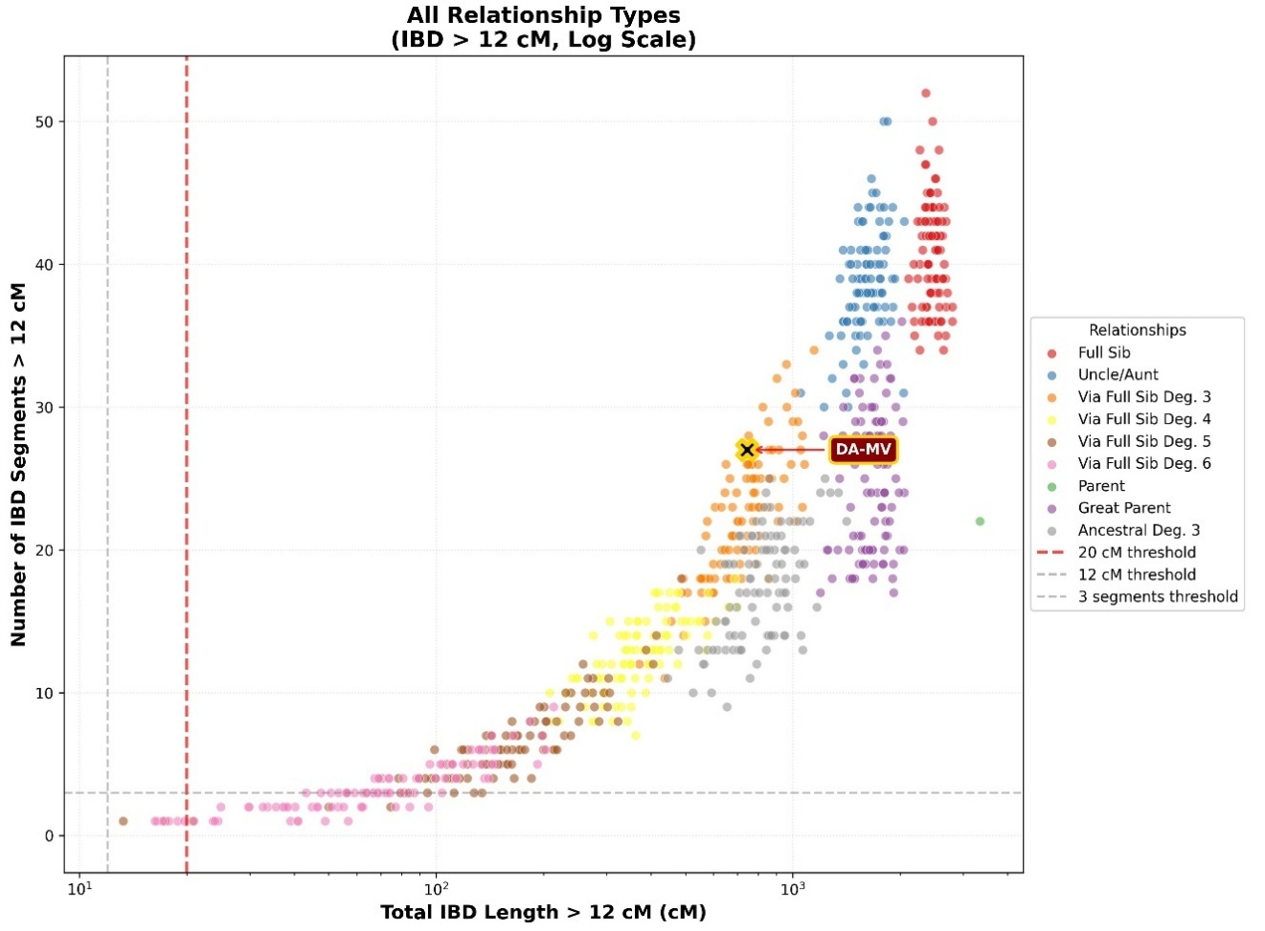
Figure 1. Distribution of the number of IBD segments and the total length of IBD segments longer than 12 cM for pairs of samples with different degrees of relatedness.
Results of PCA Analysis
The genetic affinity of the MSh genome to other ancient (Figure 2) and modern (Figure 3) populations was assessed using principal component analysis (PCA). In the space of ancient genomes, the MSh sample is positioned east of individuals from the medieval Russia_Alan population of North Ossetia dated to 450–850 CE, representatives of the Alan variant of the Saltovo-Mayaki culture (Saltovo_Maiaki) dated to 610–775 cal CE [26], and samples of Russia_Caucasus_Medieval from the Krasnodar region (Andreyevskaya Shchel), dated to 886–992 cal CE [27].
Figure 2. Principal component analysis: projection of the genome of Princess MSh (labeled Maria_Shvarnovna) onto ancient Eurasian populations.
In close proximity to the MSh genome on the PCA plot are several representatives of the Late Iron Age from southern Uzbekistan (Rabat site in the Surxondaryo region, Uzbekistan_SurxondaryoRegion_Rabat_IA) dated to 150 BCE–50 CE [28], individuals buried in the Christian cemetery of Kara-Zhygach in northern Kyrgyzstan (1338–1339 CE) [29], and an ancient individual from the Ksyrov cemetery in southern Tajikistan dated approximately to the 2nd century BCE–1st century CE (Kushan period) [30].
The affinity to the “Kushan” individuals from southern Central Asia is likely explained by their genetic profile, which includes a substantial proportion of a Late Bronze Age steppe component, 15–20% ancestry related to local farmers of southern Central Asia / the Iranian Plateau, and 35–40% ancestry related to Anatolian farmers [30]. In contrast, the genome of Prince DA is shifted significantly eastward relative to that of Princess MSh and clusters in close proximity to Hungarian Avars, an early medieval population of Central Europe.
In the space of modern genomes, the sample of Princess MSs is located outside the Caucasian cluster and occupies an intermediate position between modern Turks and Tajiks (Figure 3).
Figure 3. Principal component analysis: projection of the MSh genome (Maria_Shvarnovna) onto modern West Eurasian populations.
These results can be explained by the fact that modern Turks are highly heterogeneous and represent a complex mixture of ancient Anatolian and Balkan populations, Caucasian/Near Eastern genetic components, and a Central Asian Turkic component in varying proportions depending on region of residence [31]. Tajiks represent a classic Indo-Iranian admixture, with the majority of their genome derived from Iranian farmer-related ancestry and steppe pastoralists of the Andronovo horizon, with a minor East Asian component [32]. In turn, the genome of Prince DA is positioned closer to the genomes of Nogais from Karachay-Cherkessia, who have previously been shown to differ substantially from most other peoples of the North Caucasus and to carry up to 20–50% East Asian ancestry [33].
Ancestry Analysis of Princess MSh Using ADMIXTURE
To assess the contribution of different “ancestral populations” to the genome of Princess MSh, an ADMIXTURE analysis was performed (Figure 4, Supplementary 2). According to the results for K = 6, the genomes of Princess MSh and Prince DA show similar patterns of ancestry decomposition; however, the Asian component (shown in pink in the plot) is less pronounced in Princess MSh compared to Prince DA, while the blue component is more prominent in Princess MSh. This blue component reaches its maximum representation in the Bronze Age population of the southeastern Iranian Plateau - Iran_ShahrISokhta.
The Iran_ShahrISokhta population is characterized by a high proportion of ancestry related to the early Neolithic population of Iran (Ganj Dareh) and an absence of ancestry associated with Anatolian Neolithic farmers [34]. The ADMIXTURE plot also includes representatives of ancient populations whose genomes are closest in ancestral composition to that of Princess MSh. Similar genetic profiles were identified in individuals from the medieval Kara-Zhygach cemetery, representatives of the Late Iron Age of southern Uzbekistan [28], some “Kushan” individuals, and representatives of the Avar Khaganate in present-day Hungary. The latter display pronounced genetic heterogeneity, including individuals with a high proportion of East Eurasian ancestry and minimal or absent Iranian Neolithic ancestry, as well as individuals with low East Eurasian ancestry and substantial Iranian Neolithic ancestry (Figure 4).
Figure 4. ADMIXTURE analysis results (K = 6) for the genome of Princess MSh.
Results of Outgroup f₃ Statistics
Outgroup f₃ statistics were calculated in the configuration f₃(MSh, candidates; Yoruba), where candidates are ancient individuals whose genomes showed affinity to the genome of Princess MSh based on PCA and ADMIXTURE analyses. The highest genetic similarity was observed between Princess MSh and representatives of the Alan variant of the Saltovo-Mayaki culture (Russia_SaltovoMayaki) from the Belgorod region [26], individuals buried in the Christian cemetery of Kara-Zhygach, and samples of Russia_Caucasus_Medieval (Andreyevskaya Shchel) (Figure 5, Supplementary 7).
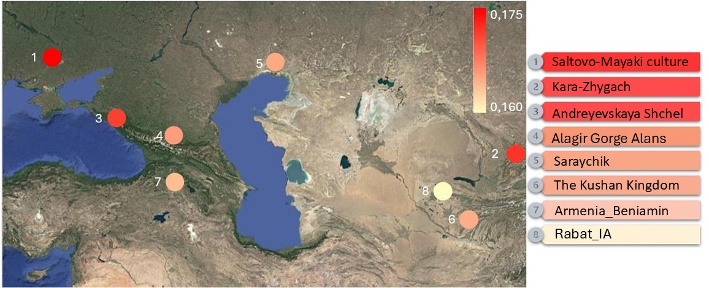
Figure 5. Genetic affinity of the MSh genome to ancient populations assessed using outgroup f₃ statistics.
Previous studies have shown that genomes of Alan representatives of the Saltovo-Mayaki culture are characterized predominantly by a Caucasus/Near Eastern genetic profile with contributions from steppe ancestry and Ancient North Eurasian (ANE) ancestry, while East Eurasian admixture is minimal or absent [26].
Individuals from Andreyevskaya Shchel cluster together with representatives of the Saltovo-Mayaki culture on the PCA plot (Figure 2) and accordingly show similar ADMIXTURE profiles (Figure 4), dominated by components related to Iranian populations and early European/Anatolian Neolithic farmers, a substantial ANE component, and minor East Asian and Nganasan-related components [27]. Given the dating of these samples, it can be assumed that representatives of both groups may have been part of the Khazar Khaganate.
In turn, individuals from the Kara-Zhygach Christian cemetery display a highly similar genetic profile to those from Andreyevskaya Shchel and the Saltovo-Mayaki culture (Figure 4), despite their later dating and much more eastern geographic location. These individuals have been shown to be successfully modeled as a mixture of two populations—AR_Xianbei_IA and Alan—with a dominant contribution from the latter [29].
The presence of East Asian and Nganasan-related components in the genomes of these populations does not contradict anthropological data indicating the presence of Mongoloid traits among populations of the Saltovo-Mayaki culture of the Lower Don and North Caucasus, especially among women [35–37]. Thus, populations showing the greatest genetic similarity to the genome of Princess MSh are characterized by a substantial proportion of Iranian-associated ancestry. Similar proportions of major components likely reflect a shared genetic substrate among these groups, representing different regional and chronological manifestations of a single West Eurasian genetic continuum extending from the North Caucasus and the Pontic region to Central Asia and the Tien Shan.
Modeling the Genetic Origin of Princess MSh
Modeling of the genetic profile of Princess MSh using qpAdm demonstrated that her genome can be successfully modeled as deriving from a single source represented by individuals from the Kara-Zhygach cemetery, “Kushan” individuals, a medieval sample from Kazakhstan dated to 685–878 cal CE, and representatives of the Alan forest-steppe variant of the Saltovo-Mayaki culture, indicating high genetic similarity to these populations (Supplementary 8). A model using Russia_Caucasus_Medieval samples did not reach statistical significance. No genetic continuity was detected when modeling with single-source Avar populations (Supplementary 9).
However, genomes of various representatives of the Avar Khaganate from present-day Hungary yielded statistically significant models when used as one of two sources in qpAdm modeling. Robust models were obtained in combination with populations displaying genetic profiles similar to that of Princess MSh: individuals from Kara-Zhygach, “Kushan” individuals, the medieval Kazakhstan sample, and representatives of the Alan, forest-steppe variant of the Saltovo-Mayaki culture (Figure 6, Supplementary 10). Statistically supported models were also obtained using ancient Russia_Caucasus_Medieval samples, medieval Russia_Alan populations from North Ossetia [26], the Armenia_Beniamin_EarlyMedieval population dated to 431–545 cal CE [38], and representatives of the Late Iron Age of southern Uzbekistan.

Figure 6. qpAdm modeling of the genome of Princess MSh using two source populations.

In addition to Avar populations, statistically supported models were obtained in combinations with ancient populations from Kazakhstan and Kyrgyzstan (Supplementary 11). In total, eight populations yielded valid two-source models for the genome of Princess MSh: representatives of the Alan, forest-steppe variant of the Saltovo-Mayaki culture, samples from the Andreyevskaya Shchel burial ground, the medieval Russia_Alan population of North Ossetia, the Armenia_Beniamin_EarlyMedieval population, representatives of the Late Iron Age of southern Uzbekistan, the medieval Kazakhstan_Medieval (Saraychik) sample, individuals from the Kara-Zhygach cemetery, and populations of the Kushan Kingdom. The chronological and historical-ethnic context of these populations is provided in Supplementary 12.
It is important to note that not all Avar populations perform equally well in two-source modeling of the genome of Princess MSh, which reflects their substantial genetic heterogeneity [39–41]. Avar populations with a high proportion of East Eurasian ancestry yielded statistically robust models when combined with “Kushan” individuals, representatives of the Saltovo-Mayaki culture, ancient samples from Andreyevskaya Shchel, the medieval Russia_Alan population of North Ossetia, the Armenia_Beniamin_EarlyMedieval population, and representatives of the Late Iron Age of southern Uzbekistan. All these populations share a minimal representation of Asian and Siberian components in their genomes. In contrast, the medieval Kazakhstan sample, which carries substantially higher proportions of Asian and Siberian ancestry, forms robust models only in combination with Avar populations in which this component is absent or minimal. Only for individuals from the Kara-Zhygach cemetery did 37 out of 39 Avar populations yield valid models, consistent with the results of single-source modeling (Supplementary 8). The smallest number of valid models in combination with Avar populations was observed for the medieval Kazakhstan sample, likely due to its low proportion of Iranian Neolithic ancestry (Figure 6). Modeling using ancient Old Russian/Slavic genomes did not produce statistically supported models (Supplementary 11).
Comparison of Genome Modeling Results for Princess MSh and Prince DA
According to PCA and ADMIXTURE analyses, the genome of Princess MSh is characterized by a higher proportion of Iranian-related ancestry, whereas the genome of Prince DA exhibits a more pronounced East Eurasian (Asian) component. When modeling the origin of Princess MSh using three sources that were suitable for modeling the genome of Prince DA, no statistically supported models were obtained. In contrast, the genome of Prince DA could be successfully modeled using two sources that were suitable for modeling the genome of Princess MSh— “Kushan” individuals, the medieval Russia_Alan population, and individuals from the Kara-Zhygach cemetery—in combination with certain Avar populations, although not the same Avar groups that yielded valid models for Princess MSh (Appendices 13–14).
Thus, despite the biological relationship between Princess MSh and Prince DA, their genomes differ substantially. This observation further highlights the complex nature of interethnic interactions in the formation of the medieval Rus’ elite and the diversity of ethnic origins of women married into the ruling dynasties.
CONCLUSION
The obtained data confirm the chronicle-based chronology and the great-grandmother–great-grandson relationship between Princess MSh and Prince DA, allowing for a confident assertion of reliable genetic identification of ancient representatives of the Rurikid princely dynasty. The genome of the princess has a complex structure: three major genetic components are associated with Iranian farmers, Anatolian farmers, and Western European hunter-gatherers, while two minor components are represented by East Asian and Siberian hunter-gatherers.
Multivariate statistical characterization of the MSh genome indicates two most probable proximal genetic sources of her origin: an Alan source, understood in a broad cultural-historical sense encompassing populations of the Early and High Middle Ages, and an East Eurasian source. Among medieval populations, the closest genetic affinities to the genome of Maria Shvarnovna are observed in representatives of the Alan forest-steppe variant of the Saltovo-Mayaki culture (inhabitants of the forest-steppe Don region), formed as a result of the migration of Alan tribes integrated into the Khazar Khaganate, as well as in individuals from the Kara-Zhygach necropolis (14th century), whose genomes also consist of a dominant Alan and a minor East Eurasian component.
These results support the Alan hypothesis and reject the Czech origin of Maria Shvarnovna. Notably, phenotypic predictions for Princess MSh (Supplementary 4) are consistent with historical descriptions, including the famous account of the Alan-Tanaite peoples by Ammianus Marcellinus written at the turn of the 4th–5th centuries CE: “Almost all Alans are tall and handsome, their hair is somewhat fair, and their gaze, though not savage, is nevertheless fierce…” [42]. Future studies may allow a more precise localization of the Alan lineage of her ancestry to specific regions of the North Caucasus, the Saltovo-Mayaki cultural sphere, or other centers of medieval Alan/As populations.
ACKNOWLEDGEMENTS
This study would not have been possible without the assistance of Metropolitan Evlogy of Vladimir and Suzdal (1937–2020), who granted his blessing for the sampling of a micro-specimen from the lower incisor of Individual No. 1 for genetic analysis. We express our sincere gratitude to Z. K. Kusaeva, E. I. Karazhaeva, and the Alanian Heritage Foundation for transferring the sample to a domestic paleogenetic laboratory.
This work was supported by funding from the State Assignment project No. 124060400040-3.
REFERENCES
- Zhur KV, Sharko FS, Sedov VV, et al. The Rurikids: The First Experience of Reconstructing the Genetic Portrait of the Ruling Family of Medieval Rus’ Based on Paleogenomic Data. Acta Naturae. 2023;15(3(58)):50–65. doi:10.32607/actanaturae.23425
- Voronin NN. Architecture of North-Eastern Rus’, 12th–15th Centuries (in two volumes). 1961; Vol. 1. (In Russian)
- Complete Collection of Russian Chronicles (Polnoe sobranie russkikh letopisei). (In Russian)
- Complete Collection of Russian Chronicles. Vol. I: The Laurentian Chronicle (Polnoe sobranie russkikh letopisei. T. I: Lavrent’evskaya letopis’). (In Russian)
- Borutskaya SB, [co-authors as in the original: VSV, LO, NSA, PTD, FSYu]. Anthropological identification of remains from the Holy Dormition Knyaginin Convent in Vladimir. In: Kusaeva ZK, Karazhaeva EI, eds. Grand Princess Maria Yasynya in Russian History. Moscow: Institute of Russian History, RAS; North Ossetian Institute for Humanities and Social Studies (V.I. Abaev), Vladikavkaz Scientific Center, RAS. 2019:179–226. (In Russian)
- Averyanov KA. Mysteries of the Burial in the Knyaginin Monastery. Published online 2023. (In Russian)
- Merkulov VI. Alexandra Bryachislavna of Polotsk: The Attribution of the Burial from the Perspective of DNA Genealogy. 2024. (In Russian) Available at: http://www.ianlogan.co.uk/
- Merkulov VI. Vasilisa from the Knyaginin Monastery in Vladimir: Problems and Prospects of DNA Studies. In: To the Anniversary of Academician A.V. Lubkov: Collected Papers. Moscow; 2025:110–128. (In Russian)
- Rohland N, Glocke I, Aximu-Petri A, Meyer M. Extraction of highly degraded DNA from ancient bones, teeth and sediments for high-throughput sequencing. Nat Protoc. 2018;13(11). doi:10.1038/s41596-018-0050-5
- Bushnell B, Rood J, Singer E. BBMerge – accurate paired shotgun read merging via overlap. PLoS One. 2017;12(10). doi:10.1371/journal.pone.0185056
- Schubert M, Ermini L, Sarkissian CD, et al. Characterization of ancient and modern genomes by SNP detection and phylogenomic and metagenomic analysis using PALEOMIX. Nat Protoc. 2014;9(5). doi:10.1038/nprot.2014.063
- Martin M. Cutadapt removes adapter sequences from high-throughput sequencing reads. EMBnet J. 2011;17(1). doi:10.14806/ej.17.1.200
- Li H, Durbin R. Fast and accurate short read alignment with Burrows–Wheeler transform. Bioinformatics. 2009;25(14). doi:10.1093/bioinformatics/btp324
- Li H, Handsaker B, Wysoker A, et al. The Sequence Alignment/Map format and SAMtools. Bioinformatics. 2009;25(16). doi:10.1093/bioinformatics/btp352
- Jónsson H, Ginolhac A, Schubert M, Johnson PLF, Orlando L. MapDamage2.0: fast approximate Bayesian estimates of ancient DNA damage parameters. Bioinformatics. 2013;29. doi:10.1093/bioinformatics/btt193
- Mallick S, Micco A, Mah M, et al. The Allen Ancient DNA Resource (AADR): a curated compendium of ancient human genomes. Published online 2023. doi:10.1101/2023.04.06.535797
- Alexander DH, Novembre J, Lange K. Fast model-based estimation of ancestry in unrelated individuals. Genome Res. 2009;19(9). doi:10.1101/gr.094052.109
- Purcell S, Neale B, Todd-Brown K, et al. PLINK: a tool set for whole-genome association and population-based linkage analyses. Am J Hum Genet. 2007;81(3). doi:10.1086/519795
- Weissensteiner H, Pacher D, Kloss-Brandstätter A, et al. HaploGrep 2: mitochondrial haplogroup classification in the era of high-throughput sequencing. Nucleic Acids Res. 2016;44(W1). doi:10.1093/nar/gkw233
- Ringbauer H, Huang Y, Akbari A, et al. Accurate detection of identity-by-descent segments in human ancient DNA. Nat Genet. 2024;56(1):143–151. doi:10.1038/s41588-023-01582-w
- Kuhn JMM, Jakobsson M, Günther T. Estimating genetic kin relationships in prehistoric populations. PLoS One. 2018;13(4). doi:10.1371/journal.pone.0195491
- Chaitanya L, Breslin K, Zuñiga S, et al. The HIrisPlex-S system for eye, hair and skin colour prediction from DNA: introduction and forensic developmental validation. Forensic Sci Int Genet. 2018;35:123–135. doi:10.1016/j.fsigen.2018.04.004
- Walsh S, Chaitanya L, Clarisse L, et al. Developmental validation of the HIrisPlex system: DNA-based eye and hair colour prediction for forensic and anthropological usage. Forensic Sci Int Genet. 2014;9(1):150–161. doi:10.1016/j.fsigen.2013.12.006
- Baumgarten N. Généalogies et mariages occidentaux des Rurikides russes du Xe au XIIIe siècle. Pont Institutum Orientalium Studiorum. 1927;35–36.
- Ekzemplyarsky AV. Grand and Appanage Princes of Northern Rus’ in the Tatar Period (1238–1505). Vol. 2: Ruling Princes of the Vladimir and Moscow Appanages; Grand and Appanage Ruling Princes of Suzdal–Nizhny Novgorod, Tver, and Ryazan. Published online 1891. (In Russian)
- De Barros Damgaard P, Marchi N, Rasmussen S, et al. 137 ancient human genomes from across the Eurasian steppes. Nature. 2018;557(7705):369–374. doi:10.1038/s41586-018-0094-2
- Maróti Z, Neparáczki E, Schütz O, et al. The genetic origin of Huns, Avars, and conquering Hungarians. Curr Biol. 2022;32(13):2858–2870.e7. doi:10.1016/j.cub.2022.04.093
- Kumar V, Bennett EA, Zhao D, et al. Genetic continuity of Bronze Age ancestry with increased Steppe-related ancestry in Late Iron Age Uzbekistan. Mol Biol Evol. 2021;38(11):4908–4917. doi:10.1093/molbev/msab216
- Spyrou MA, Musralina L, Gnecchi Ruscone GA, et al. The source of the Black Death in fourteenth-century central Eurasia. Nature. 2022;606(7915):718–724. doi:10.1038/s41586-022-04800-3
- Narasimhan VM, Patterson N, Moorjani P, et al. The genomic formation of South and Central Asia. Preprint posted online March 31, 2018. doi:10.1101/292581
- Ece Kars M, Nazlı Bas A, Emre Onat O, et al. The genetic structure of the Turkish population reveals high levels of variation and admixture. doi:10.1073/pnas.2026076118/-/DCSupplemental
- Dai SS, Sulaiman X, Isakova J, et al. The genetic echo of the Tarim mummies in modern Central Asians. Mol Biol Evol. 2022;39(9). doi:10.1093/molbev/msac179
- Jeong C, Balanovsky O, Lukianova E, et al. The genetic history of admixture across inner Eurasia. Nat Ecol Evol. 2019;3(6):966–976. doi:10.1038/s41559-019-0878-2
- Amjadi M.A, Özdemir YC, Ramezani M, et al. Ancient DNA indicates 3,000 years of genetic continuity in the Northern Iranian Plateau, from the Copper Age to the Sassanid Empire. Sci Rep. 2025;15(1). doi:10.1038/s41598-025-99743-w
- Balabanova M.A. Craniological characteristics of the early medieval population of the North Caucasus (based on the burial grounds Gorkaya Balka 1 and 2). In: Materials and Studies in the Archaeology of the North Caucasus. 2004:200–215. (In Russian)
- Balabanova M.A. Features of the anthropological composition of burial complexes of the Khazar period. In: Selected Current Issues of Modern Anthropology. St. Petersburg: Peter the Great Museum of Anthropology and Ethnography (MAE RAS); 2006:59–61. (In Russian)
- Batieva EF. Anthropology of the population of the Lower Don region in the Khazar period. Donskaya Arkheologiya. Published online 2001:71–101. (In Russian)
- Antonio ML, Weiß CL, Gao Z, et al. Stable population structure in Europe since the Iron Age, despite high mobility. eLife. 2024;13. doi:10.7554/elife.79714
- Csáky V, Gerber D, Koncz I, et al. Genetic insights into the social organisation of the Avar period elite in the 7th century AD Carpathian Basin. Sci Rep. 2020;10(1). doi:10.1038/s41598-019-57378-8
- Gnecchi-Ruscone GA, Szécsényi-Nagy A, Koncz I, et al. Ancient genomes reveal origin and rapid trans-Eurasian migration of 7th century Avar elites. Cell. 2022;185(8):1402–1413.e21. doi:10.1016/j.cell.2022.03.007
- Wang K, Tobias B, Pany-Kucera D, et al. Ancient DNA reveals reproductive barrier despite shared Avar-period culture. Nature. 2025;638(8052):1007–1014. doi:10.1038/s41586-024-08418-5
- Marcellinus A. Roman History. Published online 2005:310–317. (In Russian edition)

